**UNIVERSIDAD DE LAS FUERZAS ARMADAS – ESPE**

**CAREER**

**SOFTWARE ENGINEERING**

**SUBJECT**

**FUNDAMENTALS OF ENGINEERING**

**Team 03 Gamers**

**Topic: Mobility in the Quito’s Subway**

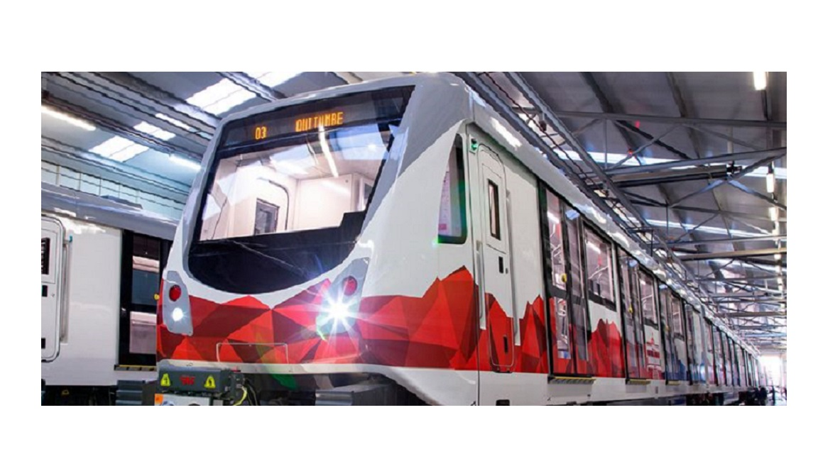

**Integrant**

**MASAPANTA GUILCATOMA JEFFERSON SANTIAGO**

**MIDEROS CRUZ SAMIR ESTEBAN**

**MOLINA GUAICO GUSTAVO STIVEN**

**MORALES SOSA JEIMY MARLEY**

**ORRICO EMME CAMILO ANDRES**

**TOPIC DESCRIPTION**

The program is based on the creation of software that controls the number of passengers, the schedules, and the administrative part:

Purchase of tickets through the identification, and control of users, if it reached the capacity limit, this would be in charge of locating it to the other wagon or in the case that all this is its maximum capacity, it sends it to the next meter that is close to to get.

Control of schedules that are available for each shift of the day so that people can be informed of the arrival of each Metro.

Administrative control, list of employees in charge of the unit and distribution, and compliance record.

Based on the interview with Ing. Rodrigo Gómez De la Torre, a member of the Quito metro development committee:

**When did you develop the Quito Metro project, did you search for or manage a digital platform that facilitates the manipulation of data, as well as the economic part and schedules?**

Those in charge of developing the Quito metro project did not propose a solution based on a program that facilitates the user's needs for transportation. So far the issue of management is still under debate and a plan to control the metro has not been determined, including ticket prices, the cost of maintenance of the units, among others. From the beginning, no management system was proposed to help the Quito metro, due to lack of experience there is not a very deep knowledge of it

**For the Quito metro to work in a more feasible way towards users that would be the solution that they would propose focused on a computer program?**

At the time of filing the interview in the conversation, the engineer in charge took us to the conclusion of implementing a security system, which will include the deployment of video cameras with built-in facial recognition, but our conclusion on this issue would not be feasible for the investment that this entails for which we seek another solution which would be a computer system, which will include an emergency button in case there is any a warning to the public order as theft, sexual harassment, verbal harassment, violence, etc

**What do you think would be the essential basis for the acquisition and purchase of tickets in the different stations of the Quito metro?**

An advance in the future could be the use of a multimodal card, the same that each user would have as identification within the Quito metro. This card would provide several facilities to the user such as monthly recharges for the purchase of tickets and thus avoid long queues, it will also provide the purchase of tickets in advance and finally, it will be possible to have a balance of users in each station to be able to manage the better way the feeders according to your need.

**What fare collection systems could the Quito metro be implemented?**

The first system to be implemented is the multimodal card, the charging system at each stop, managed by the same application software to have the same registration and user security.